**Experiment 1**

**Student Name:**Rajiv Paul **UID:**20BCS1812

**Branch:** CSE **Section/Group:** 702 A

**Semester:** 5th **Date of Performance:** 4/8/2022

**Subject Name:** DAA Lab **Subject Code:** 20-CSP-312

**1. Aim/Overview of the practical:**

Code and analyze to compute the greatest common divisor (GCD) of two numbers.

**2. Task to be done/ Which logistics used:**

To find the GCD of two numbers.

**3. Algorithm/Flowchart (For programming based labs):**

**4. Steps for experiment/practical/Code:**

**Simple Method:**

*package com.DAA*;

*import java.util.*\*;

*public class DAA_exp1_1* {

*public static void* main(*String*[] *args*) {

*Scanner* S = *new* Scanner(*System*.in);

*int* GCD=0;

*System*.out.print("enter the value of x:");

*int* x= S.nextInt();

*System*.out.print("enter the value of y:");

*int* y=S.nextInt();

*System*.out.printf("The GCD of %d and %d is ",x,y);

*while*(y!=0){

*if*(x>y){

x=x-y;

}

*else*{

y=y-x;

}

}

GCD=x;

*System*.out.printf("%d",GCD);

}

}

**Euclidean Method:**

*package com.DAA*;

*public class DAA_exp1_1_euclidean* {

*public static void* main(*String*[] *args*) {

*int* a=4,b=2;

*int* c=*GCD*(a,b);

*System*.out.println("The GCD of "+a+" and "+b+" is "+c);

}

*static int* GCD(*int x*,*int y*){

*if*(*x*==0){

*return y*;

}

*return GCD*(*y*%*x*,*x*);

}

}

**5. Observations/Discussions/ Complexity Analysis:**

Time complexity of finding GCD of two number using Euclidean method is O(log n).

**6. Result/Output/Writing Summary:**

**Simple Method:**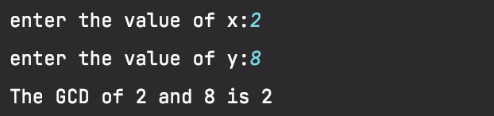

**Euclidean Method:**

**Learning outcomes (What I have learnt):**

**1. Learnt how Euclidean algorithm works.**

**2. Learnt how to use recursion for solving problem.**

**3.**

**4.**

**5.**

**Evaluation Grid (To be created as per the SOP and Assessment guidelines by the faculty):**

|  |  |  |  |
| --- | --- | --- | --- |
| Sr. No. | Parameters | Marks Obtained | Maximum Marks |
| 1. |  |  |  |
| 2. |  |  |  |
| 3. |  |  |  |
|  |  |  |  |